EXPERIMENT 2: Sketch a Simple Prototype of a Bus Ticket Booking System using Figma Tool
Step 1: Login to Figma
- Open a web browser and navigate to https://www.figma.com.
- Sign in using your Figma account credentials.
- After successful login, click New Design File.
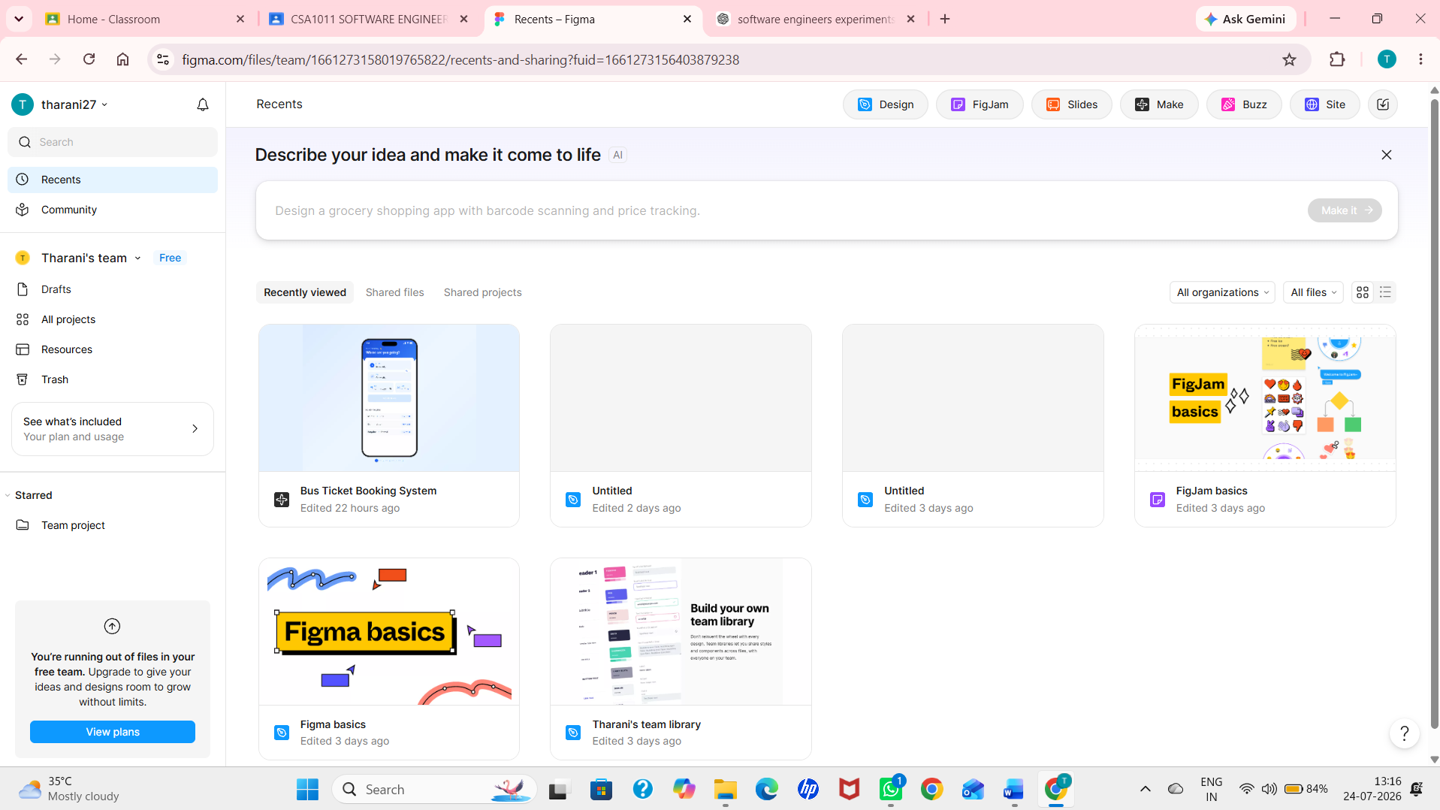

2.Create a New Design
- Click New Design File
- A blank canvas will open
3.Create a Frame
- Select the Frame Tool(F)
- Choose Desktop (eg,. Desktop (1440 x 1024)
- A desktop frame will appear on the canvas
4.Design the Login Screen
- Add a title:Bus Ticket Booking
- Insert text fields for:
  - Username
  - Password
- Add Login button
5.Create the Home Screen
- Duplicate the frame
- Add:
  - From
  - To
  - Travel Date
  - Search Buses button
6.Connect the Screens
- Switch to Prototype mode
- Connect:
- Login Home Screen
7.Preview the Prototype
- Click the Present (▶) button
- Test the Complete booking flow
